An Insight on pathogenesis of systemic lupus Erythmatosus –Induced Anemia of Chronic Diseases
Ai – Sayed – El –Manzalawy; Faisal Omran; Noha Abd Elnassar * Esnail H. Mahmoud **+ & Bashier Hamza **+
Rheumatology Department, Faculty of Medicine – Al-Azhar Benha*
Clinical Pathology Department **, Health Authority Hospitals, Riyadh, KSA & Abu Dhabi, UAE
ABSTRACT
This study aimed to assess the prevalence of anemia of chronic diseases (ACD) in patients with systemic lupus erythematosus (SLE) and the presence of antibodies to human EPO in their sera (anti- EPO antibodies). This study included 200 patients with SLE; all underwent clinical evaluation of immunologic parameters. hemoglobin concentration (Hb conc.) was determined. Blood samples were obtained for ELISA estimation of serum IL-6 and EPO levels and for ELISA testing for anti – EPO antibodies. hemogram detected 73 ACD patients (36.5%) with mean Hb conc. Of 106 ±0.8 gm/dl (Anemic group); the other 127 patients (63.5%) were either not anemic or had other types of anemia (NON – anemic group) with mean Hb conc. Of 12.9 ± 0.5 gm/dl. There was a negative significant correlation between Hb conc. and hematological score. mean serum IL-6 ESTIMATED in patients with SLE was 53.9 ± 19.9 ng/ml and was considerably (P-value ˂ 0.05). Mean serum IL-6 estimated in anemic group (60.9 ± 23.1 ng/ml was considerably higher compared both to control and non – anemic groups (49.8 ±16.5, P-value ˂ 0.05) ng/ml with a considerably higher levels of serum IL-6 in non – anemic SLE patients compared to controls mean serum EPO estimated patients with SLE was 21.2 ± 12.1 Miu/ml and anti-EPO antibodies (anti – EPO positive) were detected in 105 patients(52.5%) while the other 95 patients (47.5%) were negative for anti-EPO antibodies (anti – EPO Negative). mean serum – EPO level was significantly (p ˂ 0.05) lower in anti – EPO Negative patients (16.8± mIU /ML) compared to (anti – EPO positive patients (28.7 ±14 mIU /ML). MEAN serum EPO level was significantly (p ˂ 0.05) higher in anemic (28.9±16.8 mIU /ML) compared to non – anemic patients (16.7±3.8 mIU /ML) there was a Negative significant correlation (r= -0.331’ p ˂ 0.001) between presence of Anti – EPO antibodies and Hb conc; however, there was a non – significant difference between Hb conc. between anemic patients with and without anti – EPO antibodies or between non –anemic patients with and without anti – EPO antibodies. there was a Negative significant Correlation between Hb conc. and serum EPO ‘ (r=-0.256 ‘ p=0.028 and IL- 6’(r= -246 ‘ p=0.036) and a positive significant correlation between serum IL- 6 and EPO ‘(r= 0.238 ‘ p=0.043) EVALUATION of specificity of estimated parameters for pathogenesis of SLE – induced anemia using ROC curve analysis judged by the area under the curve (AUC) defined IL- 6 as the most specific factor (AUC = 0.827) followed by positivity for anti EPO (AUC = 0.662) and the least specific wad EPO (AUC = 0.588).it could be concluded that the frequency of SLE – induced anemia of chronic disease was 36.5% and the presence of anti - EPO antibodies and elevated IL-6 play a complementary role in its pathogenesis.

Introduction

Immature progenitors proliferate and differentiate in the bone marrow microenvironment during steady-state hematopoiesis. Through a complex network of paracrine and autocrine mechanisms including cytokines, growth hormones, and their receptors, lymphoid and non-lymphoid cells regulate hematopoesis. It is known that cytokines released locally by stromal cells promote cell proliferation and differentiation. According to stopka, miRNAs for cytokines including IL-1a, IL-1beta, IL-4, IL-6, granulocyte –macrophage colony stimulating factor, transforming growth factor – beta1 and interferon-y were identified in erythroid nrclear cells isolated from mouse spleens undergoing erythroid hyperplasia as well as in cells isolated from single erythroid colonies. Therefore, erythroid cells are cytokine-producing cells that control hemopoiesis and immunopoiesis.
Anemia is a common symptom among individuals with SLE. Despite this, autoimmune haemolytic anemia, iron deficiency anemia, drug-induced myelotoxicity, and chronic renal failure anemia remain rare disorders. Frequently, chronic diseases result in hypoproliferative anemias.
Several pathogenetic variables of systemic lupus erythematosus can influence the erythrocyte life cycle (SLE). Reduced erythropoietin activity leads to the pathophysiology of autoimmune chronic diarrhea (ACD), which is associated with other systemic autoimmune diseases. In addition, emerging study suggests that resistance to EPO activity in systemic autoimmune diseases may be linked to EPO-specific autoantibodies (anti-EPO). Almost often, systemic autoimmune lupus erythematosus is accompanied by autoantibody production. In fact, it has been demonstrated that autoantibodies directly contribute to the pathologic alterations associated with SLE.
Due to the importance of autoantibodies in the pathogenesis of SLE, their development must coincide with or precede the onset of clinical illness. Antinuclear, anti-Ro, anti-La, and anti-phospholipid antibodies commonly predate the start of SLE by several years, indicating a prolonged illness susceptibility. Others (anti-sm and anti-nuclear ribonucleoprotein antibodies) generally occur immediately before the diagnosis, a few months after the development of typical clinical symptoms. Antibodies against double-stranded DNA fall between these two kinds of antibodies. Consistent with reports of positive antinuclear, anti- Ro, anti- La, and antiphospholipid antibody tests prior to the clinical diagnosis of SLE and the absence of positive anti-SM and anti-double-stranded DNA antibody tests prior to the clinical diagnosis of SLE. Moreover, human EPO autoantibodies have recently been detected in SLE patients, and they are more frequent in anemic individuals.
The presence of such antibodies may affect the serum EPO level, or at the very least, interfere with the detection of serum EPO levels; they may also reduce the physiological impact of EPO in SLE. This prospective, randomized study aimed to determine the prevalence of ACD in patients with clinical and/or laboratory evidence of SLE, as well as to estimate serum levels of IL-6 and EPO and determine the serum positivity for anti-EPO antibodies in patients with ACD in order to assess their likely role in the pathogenesis of ACD.
Patients & Methods
This multicenter study was conducted at health authority hospitals, Abu Dhabi, UAE and AFIF GENERAL HOSPITAL, RIYADH, KSA after approval of the study protocol, 200 SLE patients. They underwent clinical and laboratory evaluation and disease activity was determined using the British isies lupus assessment group (BILAG) consisted of evaluation of 7 clinical item and hematological findings. clinical findings included general, mucocutaneous, neurologic musculoskeletal, cardiorespiratory and renal manifestations and manifestations of vasculitis to obtain a global score. SLE patients underwent laboratory assessment of serum levels of C3, C4 and C reactive protein (CRP) and total leucocytic count (TLC) Antibodies to dsDNA were measured by Farr assay according to manufacturer’s instructions hemoglobin concentration (Hb conc) was
- Determined using cyanmethemoglobin method anemia was defined by haemoglobin of ≤ 12 g/dl for women and of ≤ 13.5 g/dl for men the study included 20 normal volunteers donated blood for as control group. all study partifipants gave venous blood samples that were allowed to clot and centrifuged to separate serum which is kept frozen at -80º C till assayed for:
- Serum IL-6 was measured by ELISA from pelikine ^{Tm} Inc, Concord, USA IL-6 values in fresh serum of healthy individuals are less than 20 pg/ml (gaimes et al,1993).
- ELISA for human EPO (Quantikine IVD, R&D systems, Minneapolis, MN, USA) was used according to the manufacturer's instructions to assess serum EPO levels. Briefly, polystyrene microtitre plates coated with a murine monoclonal antibody to human EPO were exposed for one hour at room temperature to SLE sera (1.25v/v dilution). For the purpose of detecting the reaction, 0.4g/l tetramethy Ibenzidine and 0.02 percent hydrogen peroxide were added. After 15 minutes, the optical density (Od) was measured at 450 nm using an automated ELISA reader, while the reference measurement was taken at 600 nm. Individual EPO concentrations were then computed using a standard curve derived from the mean absorbance of four different standards.
- ELISA testing for human EPO antibodies (anti -EPO) was performed according to a previously described protocol with minor modifications. Recombinant EPO (R & D systems) was dissolved in phosphate buffered saline (PBS), pH 7.2, and polystyrene microtiter plates (costar, Cambridge, UK) were coated with 10g EPO per well after incubation overnight at 4o c. (ABTS; Sigma, Munich, Germany). After 30 minutes, the OD of the samples was measured at 410 nm (reference 630 nm) using a preset ELISA reader. As a baseline for absorption, each plate included ten normal human blood samples, and a total of twenty controls were analyzed; none of the controls had a significant AEA response. The positive titer threshold was 0.6 optical density (equivalent to >3 standard deviations above the mean value of the control samples), and serum y-globulin concentration was utilized to adjust the findings.
Statistical analysis:
The acquired data was presented as means ± standard deviation ranges, numbers, and ratios. The specificity of IL-6, EPO, and anti-EPO for SLE-induced ACD pathogenesis was established using the receiver operating characteristic (ROC) area under the curve (AUC). SPSS (version 10.2002) for Windows was used for statistical analysis; p-values less than 0.05 were considered statistically significant.
Results
Two –hundred patients were enrolled in the study; there were 175 female and 25 males; all had mean age of 43.3±9.4; range: 23-61 years. Fifty patients 25% presented with rash, 26 patients 13% with arthralgia / arthritis, 30 patients 15% with active renal disease, 20patients 10%with neurological manifestation and 6 patients 3%with pulmonary and pericardial disease; while the remaining 68 patients (34%) were presented with mosaic presentation, (Figure 1) mean BILAG score of studied patients was 17.6 ±9.7;9-38. Ninety –five (47.5%) had had mean BILAG score of 9.4 ± 0.5; range: 9-10.25 patients (12.5%) had mean BILAG score of13.6±3; range:11-19.54 patients (27% had mean BILAG score of 25.2±2.5; range: 22-30 and 26 patients (13 % had mean BILAG score of 35.1 ±2.3; range: 32-38 (Figure 2).
According to hematological activity scoring ; 37patients (18.5%) were scored 9.94 patients (47%) scored 3.45 patients (22.5%) scored 1and 24 patients (12%) were scored 0 immunologic assessment reported a mean c3level of 94.3± 82.4 mg/dl, c4 level of 38.9 ±42.4 mg/dl and anti-dsDNA pf 370 ± 846.5 U/I mean serum CRP was 13.7± 6.3 mg/dl and TLC was 8700 ± 2700 cell/dl, (table 1)
Hemogram was detected 73 ACD patients (36.5%) with mean Hb conc. of 10.6± 0.8; range: 8.9-11.7 mg/dl (Anemic group); the other 127 patients (63.5%) were either not anemic or had other types of anemia and all were considered as non-anemic group with mean Hb level 12.9±0.5; range:12.1-14 mg/dl mean Hb had considerably decreased in patients with hematological activity score of 9 compared to patients with other score grouping. also mean Hb had decreased significantly in patients with hematological activity score of 3 compared to patients scored 1 and 0 with insignificant levels of Hb in patients scored 1 compared to those scored 0. (Figure 3)
Moreover, there was a negative significant correlation between Hb conc and hematological activity score. (Figure 4)
The mean serum IL-6 estimated in patients with SLE was considerably higher (P-value < 0.05) compared to controls. Moreover, mean serum IL-6 estimated was significantly higher in anemic group compared both to control group and to non –anemic group with a significantly increased levels of serum IL-6 in non –anemic SLE patients compared to controls (Figure 5)
The mean serum Epo estimated in patients with SLE was 21.2 ± 12.1 mIU /ml and anti-Epo antibodies (anti – Epo positive) were detected in 105 patients (52.5%) while the other 95 patients (47.5%) were negative for anti- Epo antibodies (anti- Epo Negative) mean serum epo level was significantly (p<0.05) lower in patients had antibodies (14.4±2mIU /ml) compared to its level in those free from antibodies (28.7±142mIU /ml) mean serum epo level was significantly (p<0.05) higher in anemic (28.9±16.8; range: range: 10.1-72.1 mIU /ml) compared to non –anemic patients (16.7 ±3.8; range: 10.2-29.1 mIU /ml there was a negative significant correlation (r=-0.331, p <0.001) between presence of anti -Epo antibodies and Hb conc (Figure 2)
However, there was a non –significant difference between Hb conc. between anemic patients with and without anti- Epo antibodies and between non –anemic patients with and without anti-Epo antibodies. (Table 2)
The evaluation of correlation between estimated parameters in anemic patients, detected a negative significant correlation between Hb level and serum Epo, (r=-0.256, p=0.028) and Il-6, (r=-0.246, p=0.036) (Figure 7a and 7b) and a positive significant correlation between serum Il-6 and epo (r=-0.0.238, p=0.043) (Figure 8) but appositive non –significant correlation between serum IL-6 and positivity for anti-EPO antibodies, (r=-0.0.154, p=0.05) evaluation of specificity of estimated parameters for pathogenesis of SLE -induced anemia using the ROC curve analysis revealed that IL-6 was the most specific factor with AUC =0.827, followed by positivity for anti – EPO with AUC =0.662 and the least specific was EPO with AUC = 0.588 as factors for pathogenesis of SLE –anemia (Figure 9)

Table (1): data concerning immunological parameters evaluated in SLE patients
Parameter | Mean ± SD | Range
C3 (mg-dl) | 94.3± 82.4 | 16-597
C4 (mg-dl) | 38.9± 42.4 | 5.8-201
dsDNA (u/1) | 370± 846.5 | 7.6-4140
CRP (mg-dl) | 13.7± 6.3 | 2-32
Total leucocytic count (10³ /dl) | 8.7±2.7 | 3.5-13.7

Table (2): The patients’ distribution and mean serum levels of EPO and Hb conc in SLE patients
Parameter |  |  | Number | Mean±SD
Epo(mIU / ml) | Anti-epo | Positive | 105(52.5%) | 14.4±2
 |  | Negative | 95(47.5%) | 28.7±14*
 | ACD | Anemic | 73(36.5%) | 28.9±16.8
 |  | Non –anemic | 127 (63.5%) | 16.7±38†
Hb. conc | Anemic | Anti-Epo-positive | 23(11.5%) | 10.6±0.7
 |  | Anti-Epo-negative | 50(25%) | 10.5±0.9
 | Non-Anemic | Anti-Epo-positive | 82(41%) | 13±0.5†
 |  | Anti-Epo-negative | 45(22.5%) | 12.8±0.4†
*: significant difference versus patients with anti-Epo positive.
†: significant difference versus anemic patients.
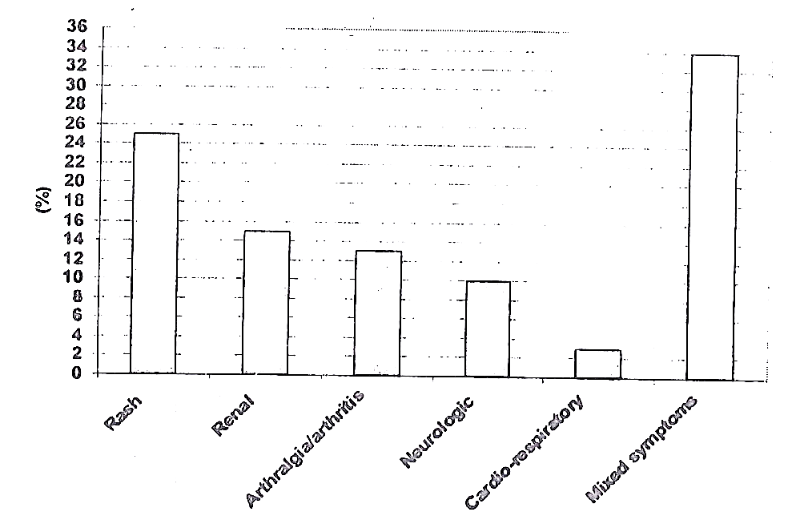
Fig (1): Patient’s Distribution according to mode of presentation
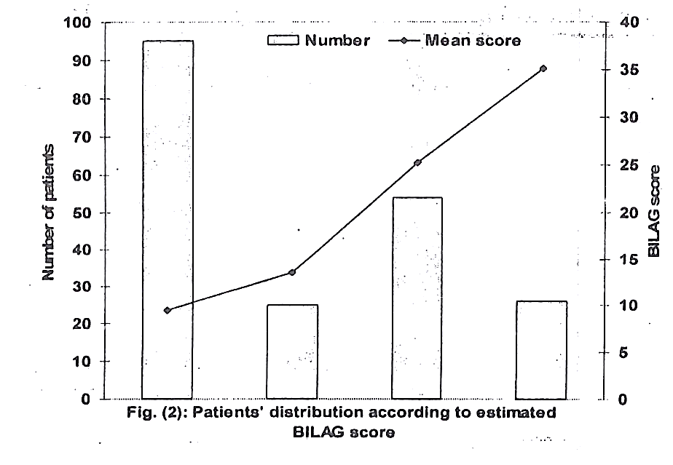
Fig (2): Patient’s Distribution according to estimated BILAG score
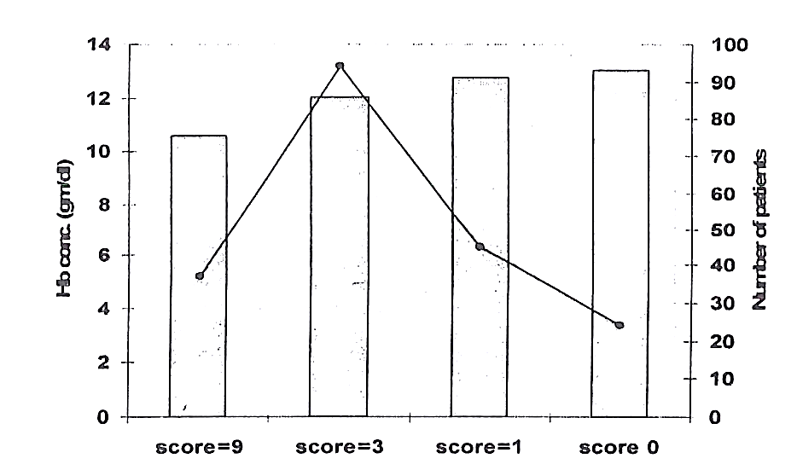
Fig (3): Patient’s Distribution according to hematological activity score and hemoglobin concentration
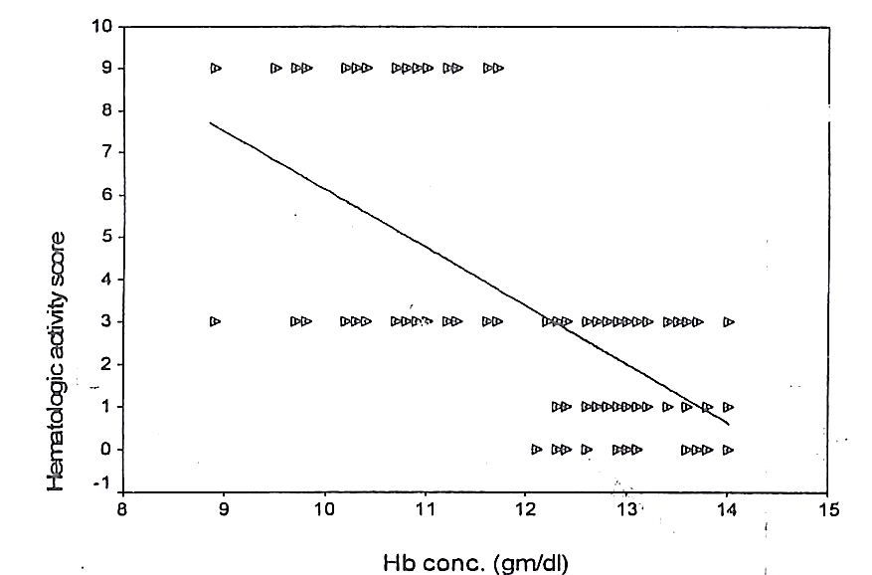
Fig (4): correlation between hematological activity score and hemoglobin concentration (gm/di)

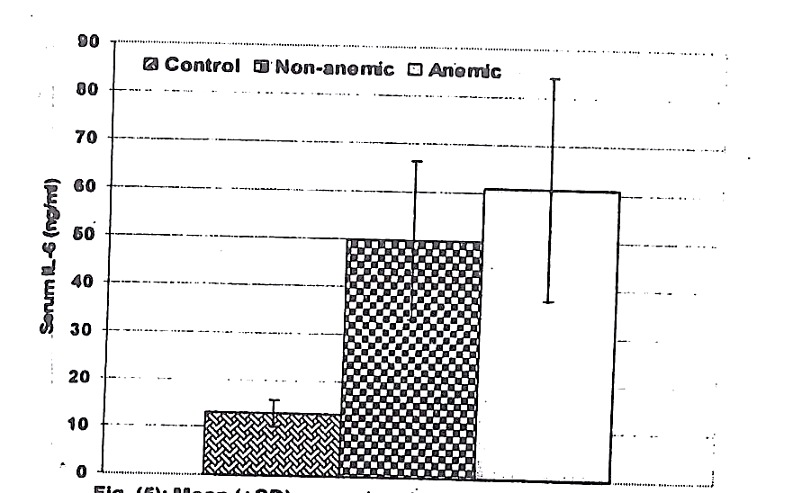
Fig. (5) Mean (SD) serum levels of IL-6 estimated in SLE Patients categorized according to the presence of ACD compared to control levels
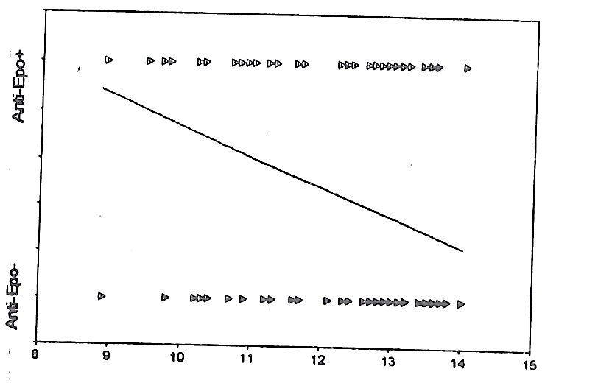
Fig. (6) correlation between presence of anti-Epo antibodies and hemoglobin concentration (gm/dl)
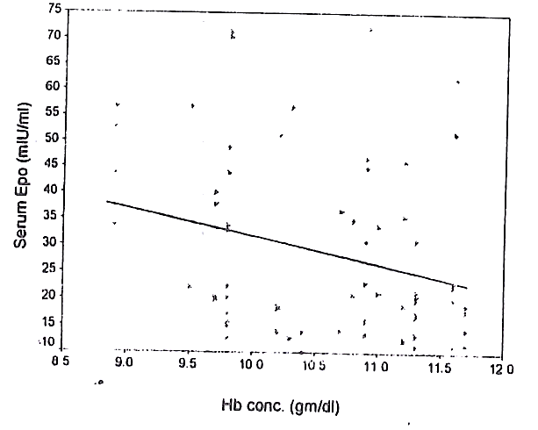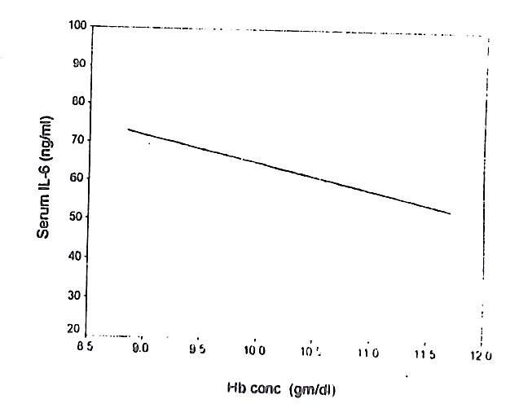
Fig. (7) correlation between serum levels of EPO (mIU/ml) and il-6 (ng/ml) and hemoglobin concentration (gm/dl) in anemic patients
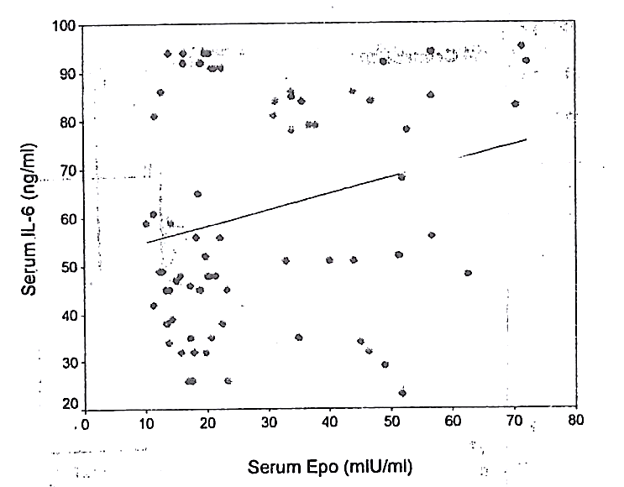
Fig. (8) correlation between serum levels Il-6 (ng/ml) EPO (gm/dl) in anemic
patient
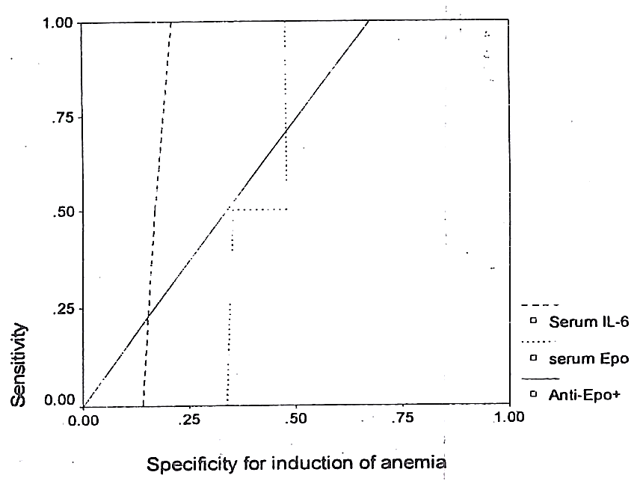
Fig. (9) ROC curve analysis for the specificity of estimated parameters for the pathogenesis of SLE-induced anemia

Discussion
Clinical evaluation conducted in the current study relied on the BILAG score for evaluation of total disease activity and for determination of hematological disease activity. Such decision goes in hand with multiple studies defined the validity of BILAG score; Griffiths et al. ⁽¹⁸⁾ found the British Isles Lupus Assessment Group (BILAG) index has been validated and has excellent reliability, validity and responsiveness to change. In addition, Yee et al. ⁽¹⁹⁾ evaluated the reliability of the British Isles Lupus Assessment Group index for the evaluation of SLE activity and determined that the BILAG index is a trustworthy instrument for evaluating SLE activity.
Mean serum IL-6 estimated in patients with SLE was significantly higher compared to its levels estimated in control group. The obtained results agreed with Grǒndal et al. ⁽²⁰⁾ reported significantly increased numbers of cells spontaneously producing IL-10 and IL-6 after mitogen phyto-haemagglutinin stimulation was also increased in SLE patients. Also, the obtained data agreed with Hrycek et al. ⁽²¹⁾ who found a significant increase in IL-6 level in SLE group compared to controls and a significant decrease in IL-6 level after 6 months of treatment, and with Asanuma et al. ⁽²²⁾ who reported that IL-6 concentrations were significantly higher in patients with lupus compared to controls.
Moreover, mean serum IL-6 was significantly higher in anemic patients compared both to controls and to non-anemic SLE patients compared to controls. These findings agreed with that previously reported by Sabry et al. ^{(23, 24)} who found the mean level of IL-6 in patients with active hematological disease significantly higher compared to those with inactive hematological disease and to the health control group. Sabry et al. in their both studies reported that findings in their series of Egyptian SLE patients and the current multicenter study enrolled patients from KSA and AUE, indicating a possible role of IL-6 in pathogenesis of hematological manifestations of SLE and is related to disease activity irrespective of the racial or environmental factors. In support of this, both studies reported a negative significant correlation between Hb conc. And serum and IL-6.
People need an intact EPO response to maintain adequate red blood cell formation and maturation and a stable haematocrit level ⁽²⁵⁾. A decrease in haematocrit, such as that caused by a hemorrhage, increases serum EPO levels in both healthy persons and those with haematological problems. This functional EPO response explains the negative correlation between hemoglobin and serum EPO levels ⁽²⁶⁾. Individuals with low haematocrit have elevated EPO levels, and vice versa. In contrast, an insufficient or suppressed EPO response with an incorrect serum EPO elevation in response to anemia is seen not only in renal illness, but also in chronic disease anemia ⁽²⁷⁾.
In accordance with these findings, the current investigation found that the mean serum EPO level of anemic patients was significantly greater than that of healthy individuals. This diminished EPO response may be attributable to the high incidence of anti-EPO antibodies, which were found in 52,5% of patients. In support of this conclusion, the mean serum EPO concentration was considerably lower in patients with antibodies compared to those without antibodies. In addition, there was a strong negative correlation between the presence of Anti-EPO antibodies and Hb concentration (r=-0.331, p0.001). Similarly, Tzioufas et al. ⁽²⁸⁾ demonstrated that the prevalence of EPO antibodies was statistically significantly higher in patients with severe anemia than in individuals without anemia.
In addition, Voulgarelis et al. ⁽²⁹⁾ discovered that the EPO response is diminished in anemic SLE patients, particularly those with ACD. Schett et al. ⁽³⁰⁾ examined erythropoietin levels and anti-erythropoietin antibodies in SLE patients and demonstrated that EPO levels were significantly decreased in SLE patients when correlated with individual hemoglobin and hematocrit values, indicating an inadequate erythropoietin response in SLE. Anti-EPO antibodies were found in 46% of SLE patients, prompting researchers to conclude that SLE-associated anemia is characterized by an inadequate EPO response.
The increased levels of EPO and IL-6 could be explained by the previous findings of Sato et al. ⁽³¹⁾ who detected EPO mRNA in erythroid cells, but not myeloid cells cultured and found that high concentrations of anti-EPO-neutralizing antibody inhibited erythropoiesis in cultures without exogenous EPO. Sennikov et al. ⁽³²⁾ reported that erythroid nuclear cells (ENC) in human bone marrow produce cytokines including IL-1beta, IL-2, IL-4, IL-6, interferon-y, transforming growth factor-beta1, tumor necrosis factor-a, and IL-10. Consequently, the ENC may be the source of both EPO and IL-6 discovered in our investigation, and this source may also explain the substantial positive association between EPO and IL-6.
There was no difference in Hb concentration between anemic patients with and without anti-EPO antibodies and non-anemic patients with and without anti-EPO antibodies in the present research. This conclusion concurred with that of et al. ⁽³⁰⁾, who reported no significant difference in hemoglobin or hematocrit levels between patients with and without anti-EPO antibodies and concluded that these antibodies are not related with an increased severity of SLE-associated anemia.
The reported non-significant difference in hemoglobin concentration irrespective of the presence of anti-EPO antibodies spotlight on the fact that the presence of anti-EPO was not the sole factor for the pathogenesis of SLE- induced ACD. Numerous investigations conducted on human hematopoietic progenitor-cell cultures shown that the IL-6/IL-6R complex stimulates the growth, proliferation, and differentiation of hematopoietic progenitor cells and erythropoietin-independent erythropoiesis, on the other hand. Chan et al. discovered that the combination of recombinant human soluble interleukin 6 receptor (sIL-6R) and IL-6, but not sIL-6R or IL-6 alone, can promote the proliferation, differentiation, and terminal maturation of erythroid cells in the absence of EPO from purified human CD34+ cells in suspension culture.
Liu et al. found no significant elevation of serum sIL-6R in active SLE.
Analysis of these experimental data could define an axis for the development and maintenance of SLE-induced ACD; the development of anti-EPO antibodies blunts the effect of EPO on proliferation and maturation of erythrocytes with a corresponding increase of ENC that secreted increased quantities of EPO and IL-6 for induction of proliferation and maturation of erythrocytes, but the action of both anti-EPO antibodies and lack of IL-6R. Such an explanation and development axis might explain the higher blood levels of EPO and IL-6 seen in our study. The ROC curve analysis of the collected data indicated IL-6 as a key component in the maintenance of SLE-induced ACD.

Conclusion
The existence of anti-EPO antibodies and increased IL-6 have a complementary function in its etiology. The prevalence of SLE-induced chronic illness anemia was determined to be 36.5%.
References

1, S.V.; Krysov S.V; Silkov A.N.; Injelevskaya T.V. & Kozlov V.A. (2002): Production of IL-10, TNF-alfa, IFN-gamma, TGF-beta1 by different populations of erythroid cells derived from human embryonal liver. Cytokine; 17: 221-5.

2. Sennikov S.V.; Eremina L.V.; Injelevskaya T.V.: Krysov S.V.; Silkov A.N. & Kozlov V.A. (2001) Cytokine-Synthesizing Activity of Cells. Russ J Immunol.; 6:193-202. 3. T.; Zivny J.H.; Stopkova P.; Prchal J.E. & Prchal J.T. (1998): Human Hematopoietic Progenitors Express Erythropoietin. Blood; 91:3766-72.

4. Vlachoyiannopoulos P.G.; Karasa F.B.; Karakostas K.X.; Drosos A.A. & Moutsopoulos H.M. (1993) Systemic lupus erythematosus in Greece. Clinical features, evolution and a descriptive analysis of 292 patients. Lupus; 2:303-12.

5. Keeling D.M. & Isenberg D.A.

(1993): Haematological manifestations of systemic lupus erythematosus. Blood Rev.; 7: 199-207. 6. Quismorio F.P. (1997) Hematologic and lymphoid abnormalities in systemic lupus erythematosus. In: Wallace DJ & Hahn BH (eds.) Dubois' lupus erythematosus, 5th edn. Baltimore, MD: Williams & Wilkins, pp. 793- 816.

7. Arbuckle M.R.; McClain M.T.; Rubertone M.V. ; Scofield R.H.; Dennis G.J.; James J.A. & Harley J.B. (2003) Development of autoantibodies before the clinical onset of systemic lupus erythematosus. N Engl J Med. 349 (16): 1526-33.

8. Figueredo M.A.; Rodriguez A.; Ruiz-Yagüe M. ; Romero M.; Fernandez-Cruz A.; Gomez-de la Concha E. & Patiño R. (2006): Autoantibodies. against C-reactive protein: clinical associations in systemic lupus erythematosus and primary antiphospholipid syndrome. J Rheumatol.; 33 (10): 1980-6.

9. Su Y.; Jia R.L.; Han L. & Li Z.G. (2007): Role of anti-nucleosome antibody in the diagnosis of systemic lupus erythematosus. Clin Immunol.; 122 (1): 115-20.

10.Suszek D. Majdan M.; Chudzik D. & Dryglewska M. (2006) Relations between severity of anemia and certain antiphospholipid antibodies presence in systemic lupus erythematosus patients. Pol Arch Med Wewn.; 115 (5): 426-31.

11. Stoll T.; Stucki G.; Malik J.; Pyke S. & Isenberg D.A. (1996): Further validation of the BILAG disease activity index in patients with systemic lupus erythematosus, Ann Rheum Dis. 55 (10):756-60.

12. Derksen R.H.; Bast E.J.; Strooisma T. & Jacobs J.W. (2002): A comparison between the Farr radioimmunoassay and a new automated fluorescence immunoassay for the detection of antibodies against double stranded DNA in serum. Ann Rheumatic Diseases; 61: 1099- 102.

13. International Committee for Standardization in Hematology (1967): Recommendations for hemoglobinometry in human blood. Br. J. Hematology; 13 (Suppl.1): 71.

14. Dacie J.V. & Lewis S.M. (1991): Reference ranges and normal values. In: Dacie JV & Lewis SM (eds.) Practical Haematology. New York: Churchill Livingstone, pp. 9-17.

15. Gaines-Das R.E. & Poole S. (1993): The international standard for interleukin-6- evaluation in an international collaborative study. J Immunol Methods; 160: 147-53.

16. Noe G.; Riedel W.; Kubanek B. & Rich I.N.

(1992) A sensitive sandwich ELISA for

measuring erythropoietin in human serum. Br J

Hematol.; 80: 285-92.

17. Tzioufas A.G.; Kokori S.I.; Petrovas C.I. & Moutsopoulos H.M. (1997): Autoantibodies to human recombinant erythropoietin in patients with systemic lupus erythematosus. Arthritis Rheum; 12: 2212-6.

18.Griffiths B.; Mosca M. & Gordon C. (2005): Assessment of patients with systemic lupus erythematosus and the use of lupus disease activity indices. Best Pract Res Clin Rheumatol.:19 (5): 685-708.

19. Yee C.S.; Farewell V.; Isenberg D.A.; Prabu A. ; Sokoll K.; Teh L.S.; Rahman A.; Bruce L.N.; Griffiths B.; Akil M.; McHugh N.; D'Cruz D.; Khamashta M.A.; Bowman S.; Maddison P.; Zoma A.; Allen E.; Gordon C. & British Isles Lupus Assessment Group (2006): Revised British Isles Lupus Assessment Group 2004 index: a reliable tool for assessment of systemic lupus erythematosus activity. Arthritis Rheum.; 54 (10): 3300-5.

20. Gröndal G.; Gunnarsson I.; Rönnelid J.; Rogberg S.; Klareskog L & Lundberg I. (2000): Cytokine production, serum levels and disease activity in systemic lupus erythematosus. Clin Exp Rheumatol.; 18 (5): 565-70.

21. Hrycek A.; Cieślik P.; Tustanowski J.; Nowak S. & Jedynak P. (2001): Selected serum cytokines in systemic lupus erythematosus treated with quinagolide. Lupus: 10 (6): 424- 30.

22. Asanuma Y.; Chung C.P.; Oeser A.; Shintani A.: Stanley E.; Raggi P. & Stein C.M. (2006): Increased concentration of proatherogenic inflammatory cytokines in systemic lupus erythematosus: relationship to cardiovascular risk factors. J Rheumatol.; 33 (3): 539-45.

23.Sabry A.; Elbasyouni S.R.; Sheashaa H.A.; Alhusseini A.A.; Mahmoud K.; George S.K.; Kaleek E.A.; Abo-Zena H.; Kalil A.M. Mohsen T.; Rahim M.A. & El-samanody A.Z. (2006): Correlation between levels of TNF. alpha and IL-6 and hematological involvement in SLE Egyptian patients with lupus nephritis. Int Urol Nephrol.: 38 (3-4): 731-7.

24.Sabry A. Sheashaa H.; El-Husseini A.; Mahmoud K.; Eldahshan K.F.; George S.K.; Abdel-Khalek E.; El-Shafey E.M. & Abo-Zenah H. (2006) Proinflammatory cytokines (TNF. alpha and IL-6) in Egyptian patients with SLE: its correlation with disease activity, Cytokine: 35 (3-4):148-53.

25. Krantz S.B. (1991): Erythropoietin. Blood; 77:

419-34. 26. Krantz S.B. (1995): Erythropoietin and the anaemia of chronic disease. Nephrol Dial Transplant; 10: 10-17.

27.Cameron J.S. (1999): Towards the millennium: a history of renal anaemia and the optimal use of epoetin. Nephrol Dial Transplant; 14 (Suppl.

2): 10-21.

28. Tzioufas A.G.; Kokori S.I.; Petrovas C.I. & Moutsopoulos H.M. (2000): Autoantibodies to human recombinant erythropoietin in patients with systemic lupus erythematosus: correlation with anemia. Ann Rheum Dis. ; 59 (3):217-22.

29. Voulgarelis M.; Kokori S.I.; loannidis J.P.; Tzioufas A.G.; Kyriaki D. & Moutsopoulos H.M. (2000) Anaemia in systemic lupus erythematosus: aetiological profile and the role of erythropoietin. Ann Rheum Dis.; 59 (3): 217 -22.

30.Schett G.; Firbas U.; Füreder W.; Hiesberger H.; Winkler S.; Wachauer D.; Köller M.; Kapiotis S. & Smolen J. (2001): Decreased serum erythropoietin and its relation to anti- erythropoietin antibodies in anaemia of systemic lupus erythematosus. Rheumatology (Oxford): 40 (4): 424-31.

